**Assignment:** SFM-03-Assignment

**Submitted By: Sandesh Sunkishala**

**INSTRUCTIONS**:

1. Use the MS Excel File “XL_FILE_SFM-03_AssignmentData” to complete this assignment. Refer to relevant sheets within this Excel file to answer the respective questions given here.

2. Upload the updated MS Excel File and this word file to submit your work.

**HINT:** Please refer to “After_Class--SFM-03- Latest In Class Solution” and lecture recording to do this assignment.

**Question 1:**

1. Compute the Standard deviation step-by-step using the raw formula as well as the built-in excel formula for SBI and SPY in the Assignment.xlsx. (refer sheet “SBI and SPY”)

**Answer 1:**

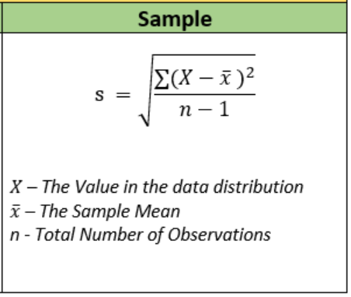

🡪As per above standard deviation formula below fields are calculated for SBI & SPY step wise.

🡪Used below formulas for above mentioned columns



🡪Final step to calculate standard deviation.



🡪With built in functions

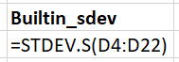

Below are the results of stepwise and built in function.

 here bold is built in sdev function.

**Question 2:**

2. Compute the Covariance step-by-step using the raw formula as well as the built-in excel formula (same two stocks as in Q1).

**Answer 2:**

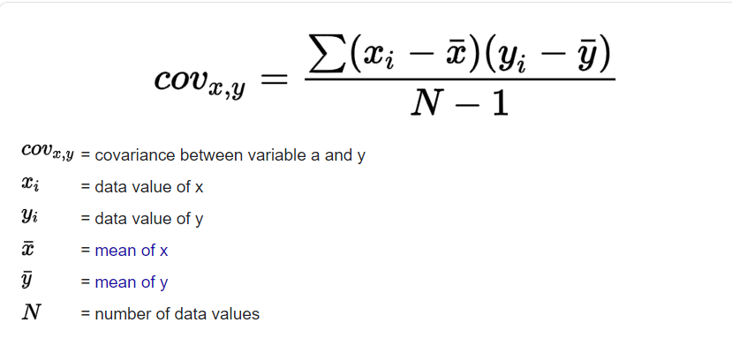

Step 1:

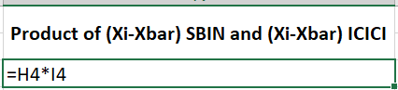

Step 2:

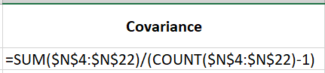

Step 3: Built in function

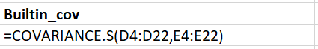

Compare Raw vs Built in:

 here bold is built in covariance function.

**Question 3:**

3.  Calculate the best possible portfolio weight distribution for same two stocks as in Q1, with a maximum standard deviation of 1%. The maximum standard deviation can be changed by the user and the output must highlight the best portfolio given the max. SD.

**Answer 3:**Step 1: Weight distribution for SBI & SPY

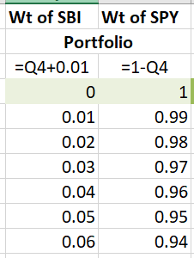

Step 2: Portfolio Returns

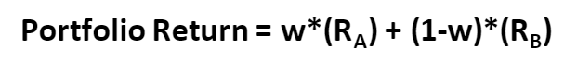

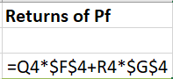

Step 3: Portfolio Variance

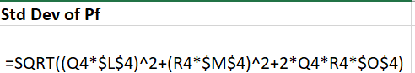

Step 4: Plot sdev vs returns chart.

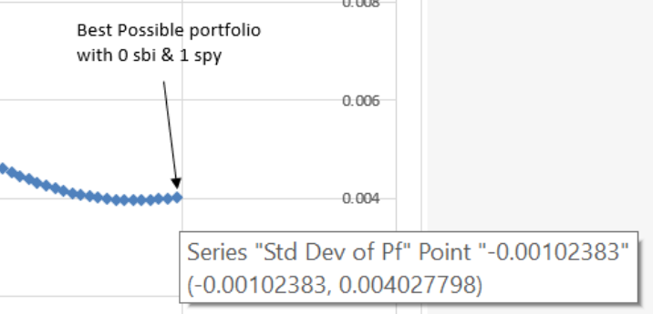

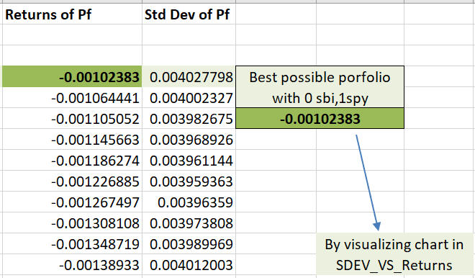

Note : As all the returns are less than zero considered the returns which is closed to zero as the best portfolio for max sdev 1%.

Step 5:

User can use the chart sdev vs returns to get best portfolio with given max. SD.

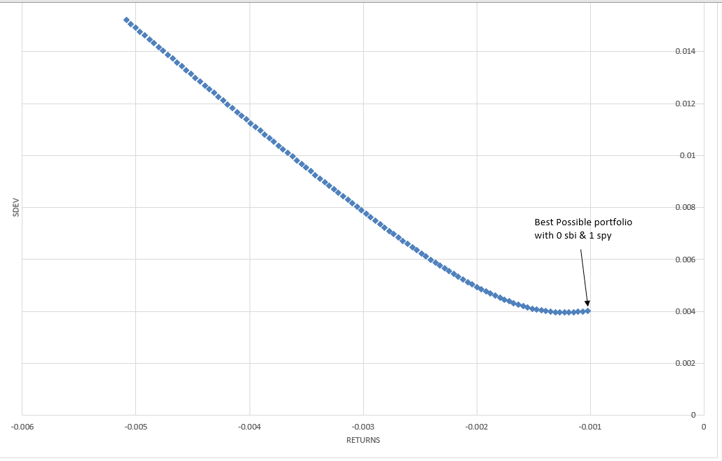

**Question 4:**

4.  Bollinger band chart for S&P500 data (using 15 day moving average and 15 day moving standard deviation). (refer sheet “SPY Bollinger Bands”)

Hint:    Lower Bollinger Band = Mean – 2*Standard Deviation

             Upper Bollinger Band = Mean + 2*Standard Deviation

**Answer 4:**

Step 1: mean 15 or middle band

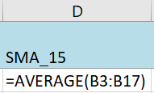

Step 2: sdev 15

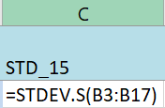

Step 3: Lower band

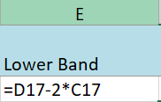

Step 4: Upper band

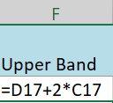

Plotting chart:

🡪select below three columns and insert line chart.



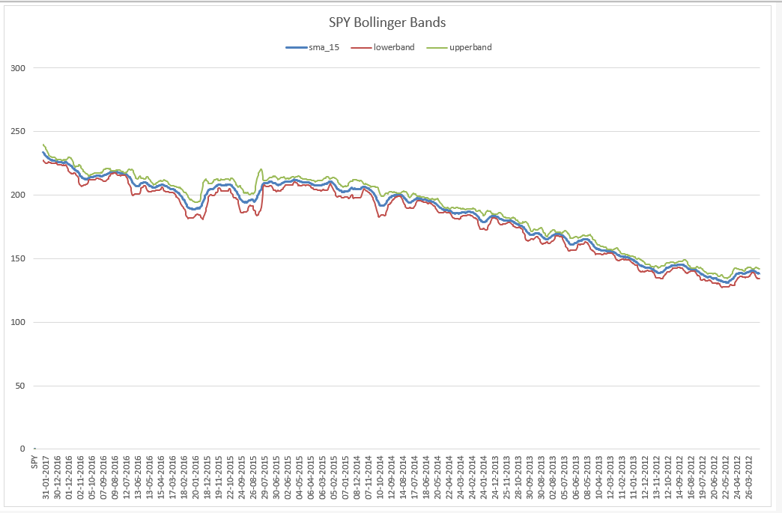**Question 5:**

5. Calculate 90% Confidence VaR value for Bank of America stock, for a period of 20 days, using the Monte Carlo Simulation. (refer sheet “Bank of America Monte Carlo”

**Answer 5:**

Step 1:Returns

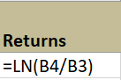

Step 2 : Avg Returns



Step 3: sdev of Daily returns



Step 4: Variance



Step 5: Monte Carlo simulation

🡪Taken 1000 observation each day up to 20 days using below formula.



Step 6: Range of Stock Price at 20th day from Simulations (90% confidence)

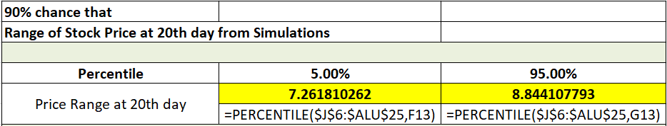

Step 7: 90% Confidence VaR value for Bank of America stock

